Lab 1 Report: Experimenting TCP using ns-3 simulator
By Bhuwan pandey
Introduction
This report represents the analysis of TCP congestion control behavior under dynamic network conditions such as link delay and packet error rate. The test was conducted using the ns-3 network simulator and seventh.cc file from the example to create a simple two-node topology.
Methodology
The default/base configuration for multiple simulations performed were 5Mbps data rate and ERROR_UNIT_PACKET as ErrorUnit; whereas packet error rate, link delay and simulation time were dynamic as per the several tests performed. The congestion window data was logged into seventh.cwnd and plotted using Gnuplot. During the simulations, the following dynamic parameter were tested:
- Dynamic delay: Error rate was fixed at 0.00001 whereas delays were in increasing order. i.e. 2ms, 50ms, 200ms, 500ms.
- Dynamic error: Link delay was fixed at 2ms whereas error rates were in increasing order. i.e. 0.00001, 0.00002, 0.00003, 0.0002, 0.02 and 0.2.
- Dynamic simulation timeout: Simulation timeout value of 20s (mostly) and 400s (Figure 1.5) were used.
Results and Analysis
As we know the Round-Trip Time (RTT) is directly determined by link delay that played crucial role on testing out the following simulations:
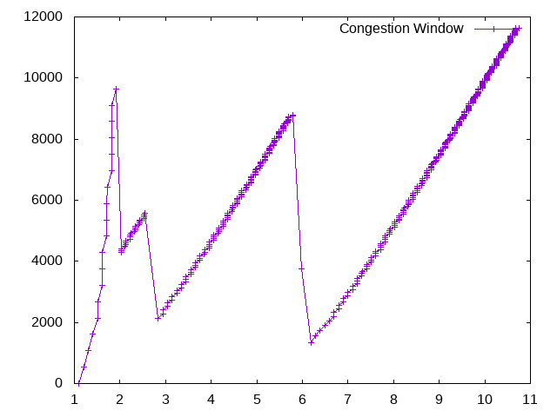  Figure 1.1 (error rate: 0.00001, link delay: 50ms, simulation timeout: 20s) | 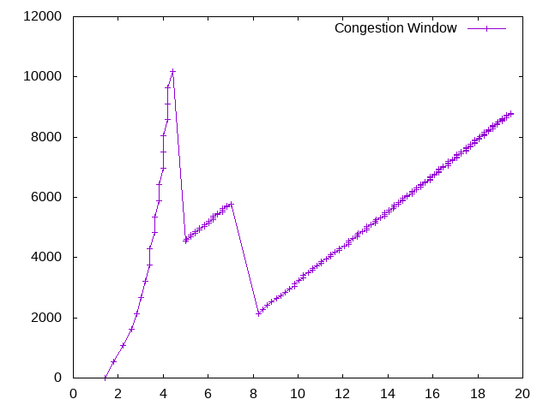  Figure 1.2 (error rate: 0.00001, link delay: 200ms, simulation timeout: 20s)
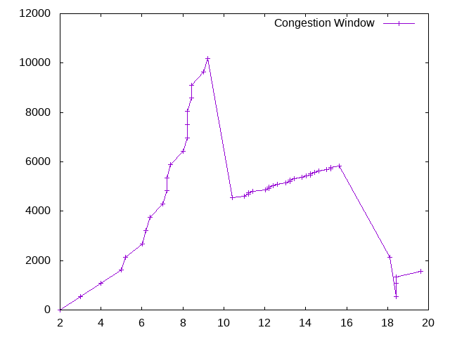  Figure 1.3 (error rate: 0.00001, link delay: 500ms, simulation timeout: 20s) | 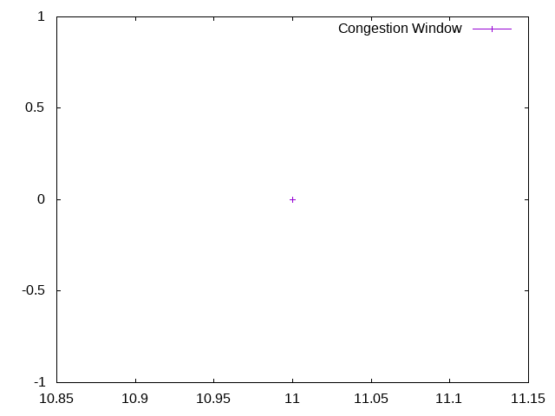  Figure 1.4 (error rate: 0.00001, link delay: 5s, simulation timeout: 20s)
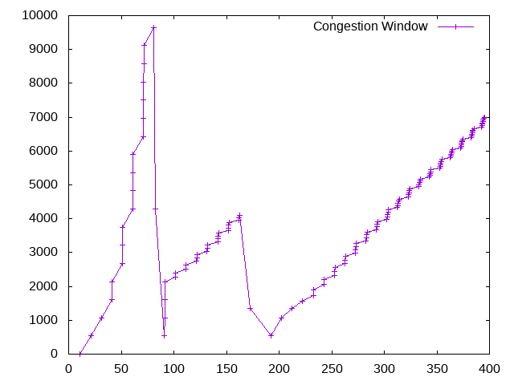
Figure 1.5 (error rate: 0.00001, link delay: 5s, simulation timeout: 400s)

The graphs (Figure 1.1 and 1.2) shows the classic fluctuation pattern for low link delays of 50ms and 200ms respectively where the congestion window grows exponentially during initial slow-start and then transitions to linear increase (AI) until a packet loss occurs after which, multiplicative decrease (MD) occurs. The high/peak frequency of the graphs indicates rapid recovery and throughput. Similarly, the graphs (Figure 1.3, 1.4 and 1.5) represents high link delay of 500ms and 5s respectively which led significant changes to the fluctuating pattern as compared to low link delays. As we can see in Figure 1.3, the linear growth phase becomes much shallower because TCP can only increase its window by one segment per RTT but the RTT here now is large. But something odd happens in Figure 1.4 as there appears no graph plots in the image. This is because the link delay of 5 seconds is too much given the simulation timeout, preventing any AI/MD events to be triggered because of the long waits. The Figure 1.5 clearly indicates that given the sufficient amount of simulation/wait time, congestion avoidance works just fine with the correct ratio of link delay and the error rate.
On the other hand, the Figures 2.1 and 2.2 below shows the continuous packet drops resulting in much narrowed data pattern. Also, the high error rate such as 0.02 and 0.2 completely breaks down the fluctuation pattern as shown in Figure 2.3. The packet drop rate being so high, led the window to halve very frequently that it never has time to grow. It results in drastically degraded throughput as TCP misinterprets high random loss as continual network congestion.
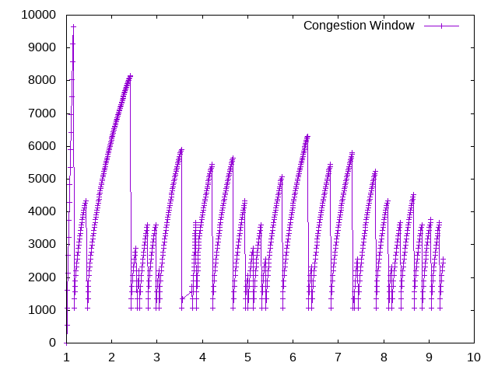  Figure 2.1 (error rate: 0.00003, link delay: 2ms, simulation timeout: 20s) | 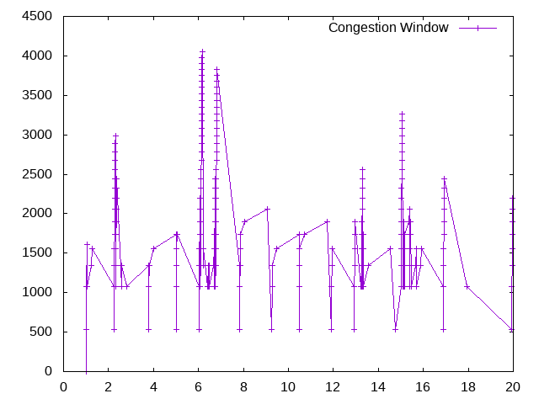  Figure 2.2 (error rate: 0.00002, link delay: 5s, simulation timeout: 20s)
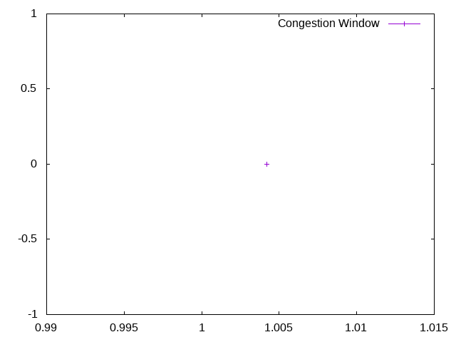
Figure 2.3 (error rate: 0.02, link delay: 5s, simulation timeout: 20s)

Conclusion
This lab successfully demonstrated the profound impact of network conditions on TCP operation. The graphs generated provide clear visual evidence of these fundamental TCP behaviors, confirming the principles of AI/MD. It clearly showed that higher delays slow down TCP’s window growth while reducing throughput and creating wider, slower fluctuation patterns. It also validated that high random packet loss leads to poor TCP performance by preventing its window from growing. Thus, use of good ratio of delay and/or error rate is very crucial to let TCP handle congestion smoothly.

